KENNEL QUILT TUTORIAL
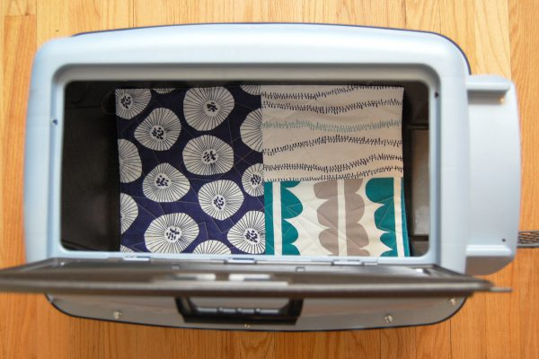
I first learned about making and donating small kennel quilts through a WeAllSew post about them a few years ago. The quilts are made to fit small animal pet carriers and kennels, and help provide a small bit of comfort to animals in shelters.
We’ve also discovered these little quilts are like magical kitty magnets! We use them on furniture where Isaac and Miss Bea find favorite nap spots to keep cat hair to a minimum. When they’re dirty we just toss them in the wash. Finished kennel quilts are 18″ x 12″ rectangles.
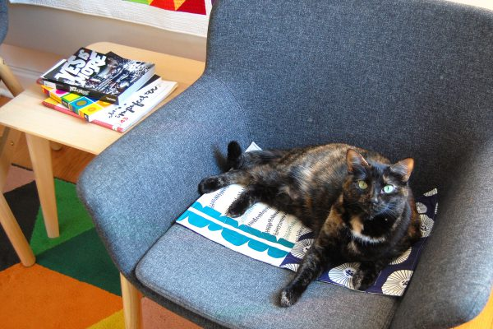
If you are an experienced quilter, you’ll be stitching up these little quilts from scraps in your stash in no time! If you’re just learning to quilt these are great first projects. I’ve also learned that kennel quilts make great learn-to-quilt project for kids.

Materials to Make a Kennel Quilt
- You can use various fabric scraps from your stash or fat quarters
- Scrap of batting to be cut to 12 1/2″ x 18 1/2″
- Coordinating thread
- Sewing machine
- Patchwork foot of your choice with seam guide
- Walking foot #50 or Dual Feed foot
- Rotary cutter, cutting mat, and quilting ruler
- Iron and pressing surface

Cutting the Kennel Quilt Pattern Pieces
First, decide what your kennel quilt top will look like. You can cut one front and one back from fat quarters, piece the top improvisation style, or create your own patchwork pattern. To complete your kennel quilt you will need the following pieces:
- Finished quilt top measuring 12 1/2″ x 18 1/2″ (can be one piece of fabric or you can create any patchwork pattern you like)
- Backing cut to 12 1/2″ x 18 1/2″
- Batting cut to 12 1/2″ x 18 1/2″
We use the no-binding method to finish the edges known as the “envelope” method. All layers are sewn together and flipped inside-out. To create an envelope finish, layer your quilt pieces on your work table as follows. First layer the batting, then the backing right side up, then the top right side down.
Pin through all layers. Leave an opening about 3″ – 4″ along one edge of the quilt (doesn’t matter which edge, your choice!) to turn the quilt inside-out. I mark the opening with horizontal pins as a reminder of where to start and stop sewing by the opening.
We use the same settings as sewing the patchwork with sewing speed dialed down and using the patchwork foot with seam guide to create a perfect quarter-inch seam.
After stitching around all edges, clip the corners close to the stitching to help make the corners turn out nicely.
Use the opening to turn the quilt inside-out. Use a pencil eraser, blunt end of a chopstick, or point turner to gently push the corners out. Turn the fabric at the openings in 1/4″ and press in place. Press around the edges of the quilt to make them nice and flat.
Top stitch all around the outside of the quilt with a scant quarter-inch seam, making sure to sew the opening closed.
Set up the sewing machine for quilting.
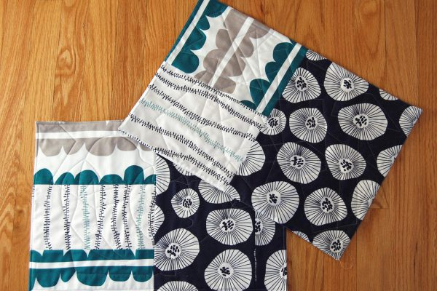
You can get in touch with local animal shelters in your area to ask if they accept donations of kennel quilts, or visit the official TQPM Kennel Quilts for The Quilt Pattern Magazine website here.
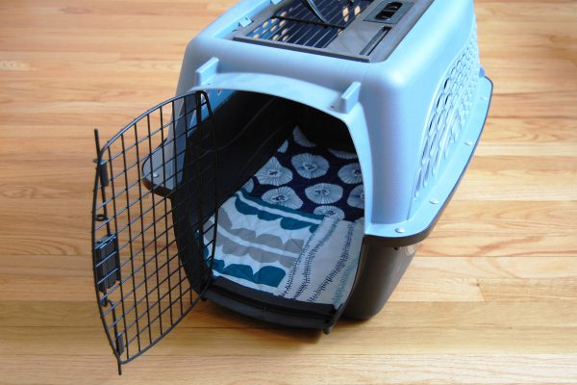
Difficulty level: Beginner
Time to Complete: Evening
Used Material: 2 or more fat quarters, coordinating thread, quilt batting
Guidelines for Small Kennel Quilts:
- Materials used should be 100% cotton (biodegradable) (Do not use flannel for it sheds too much).
- Pre-wash fabrics (pets can have allergies just like humans).
- Finished size should be 12" x 18". This fits the most commonly used small kennel used at shelters.
- When piecing, use a small stitch length (e.g. 14 stitches/inch).
- Do not use binding as it can be hazardous to pets if it becomes loose. Layer, sew around the edge using a small stitch length, and turn quilts pillow-cover style. Whipstitch the opening with small, tight stitches.
- Use only simple appliques that are secured with tight stitches along the edges. Avoid using fusibles.
- Keep the quilting simple and use small tight quilting stitches that won’t catch on pet claws. Do not tie quilts as the ends can get caught in claws or chewed off.
- Do not use any metallic threads or other embellishments (e.g. beads, charms, buttons, ribbons, lace, trims, etc.) of any kind. Do not add handles or loops to the quilt.
https://www.quiltpatternmagazine.com/program/KennelQuilt/#Guidelines

Also, check this site for free patterns! The Kennel Quilt size is perfect for an orphan 12” x 12” block with 3” of a coordinating fabric on each side.

