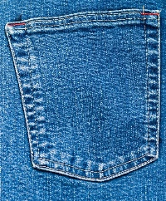Guild Challenge 2017
“Pick a pocket”
- The Maximum size is 18 x 24
- You may use a maximum of 3 pockets.
- You must incorporate a piece of fabric that is the same color as the stitching on the pocket. If more than one pocket is used, you must use a piece of fabric that matches each stitching color.
- You may incorporate additional denim that came with the pocket.
- The only non-fabric embellishments allowed are buttons.
- You may not alter the shape of the pocket.
- Only Piedmont Quilters Guild members can participate.
If you have any questions, please contact Patti Stiles at pstiles3@gmail.com or Paula Becker at pmkbecker@aol.com

